Application Execution Screenshots

- Executing the data generator to produce mysql records at rate of 1 record/second.

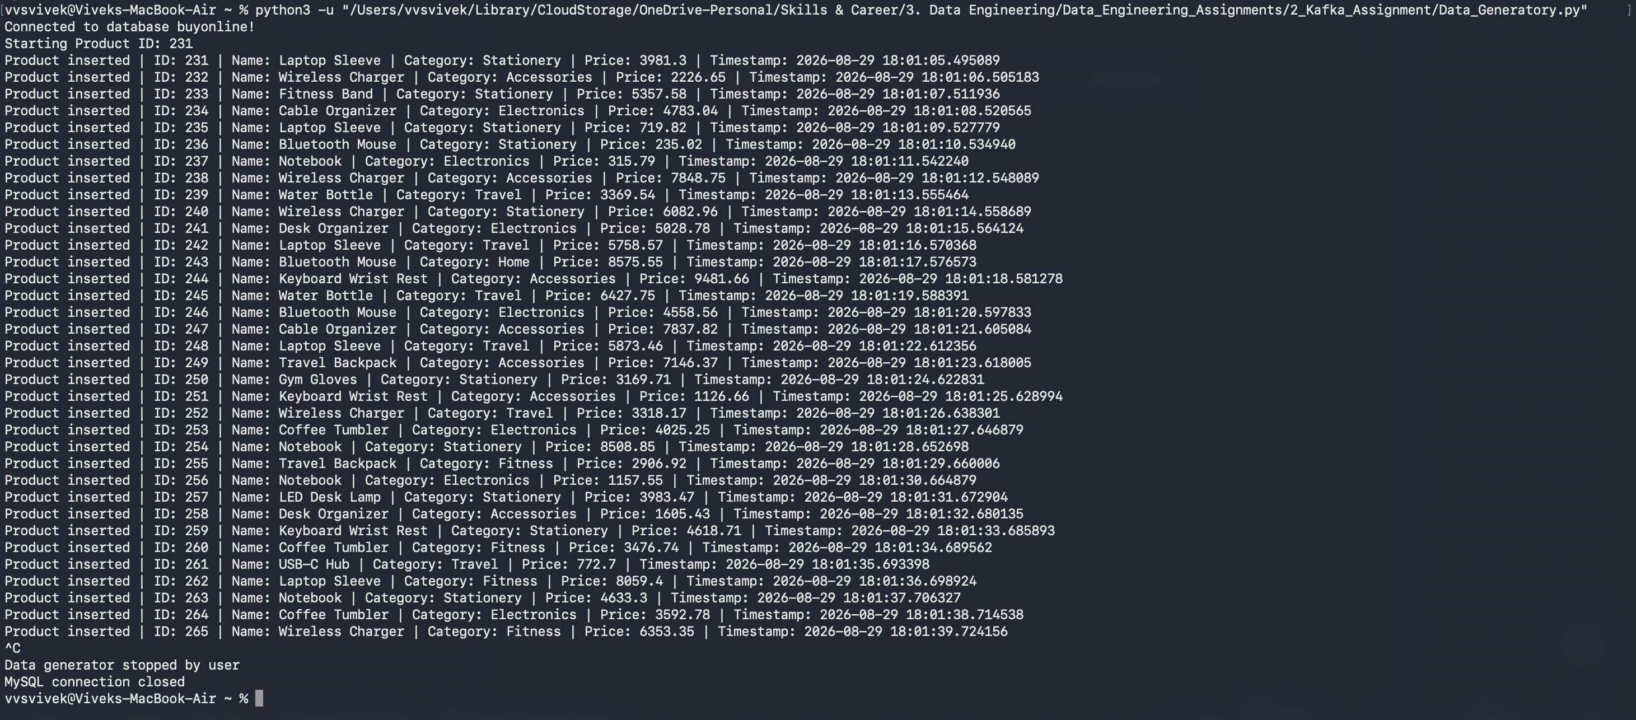

- Executing the producer. It will first check the last processed time stamp from the checkpoint file. Based on that it will fetch data only updated after that timestamp and send that data to kafka topic.
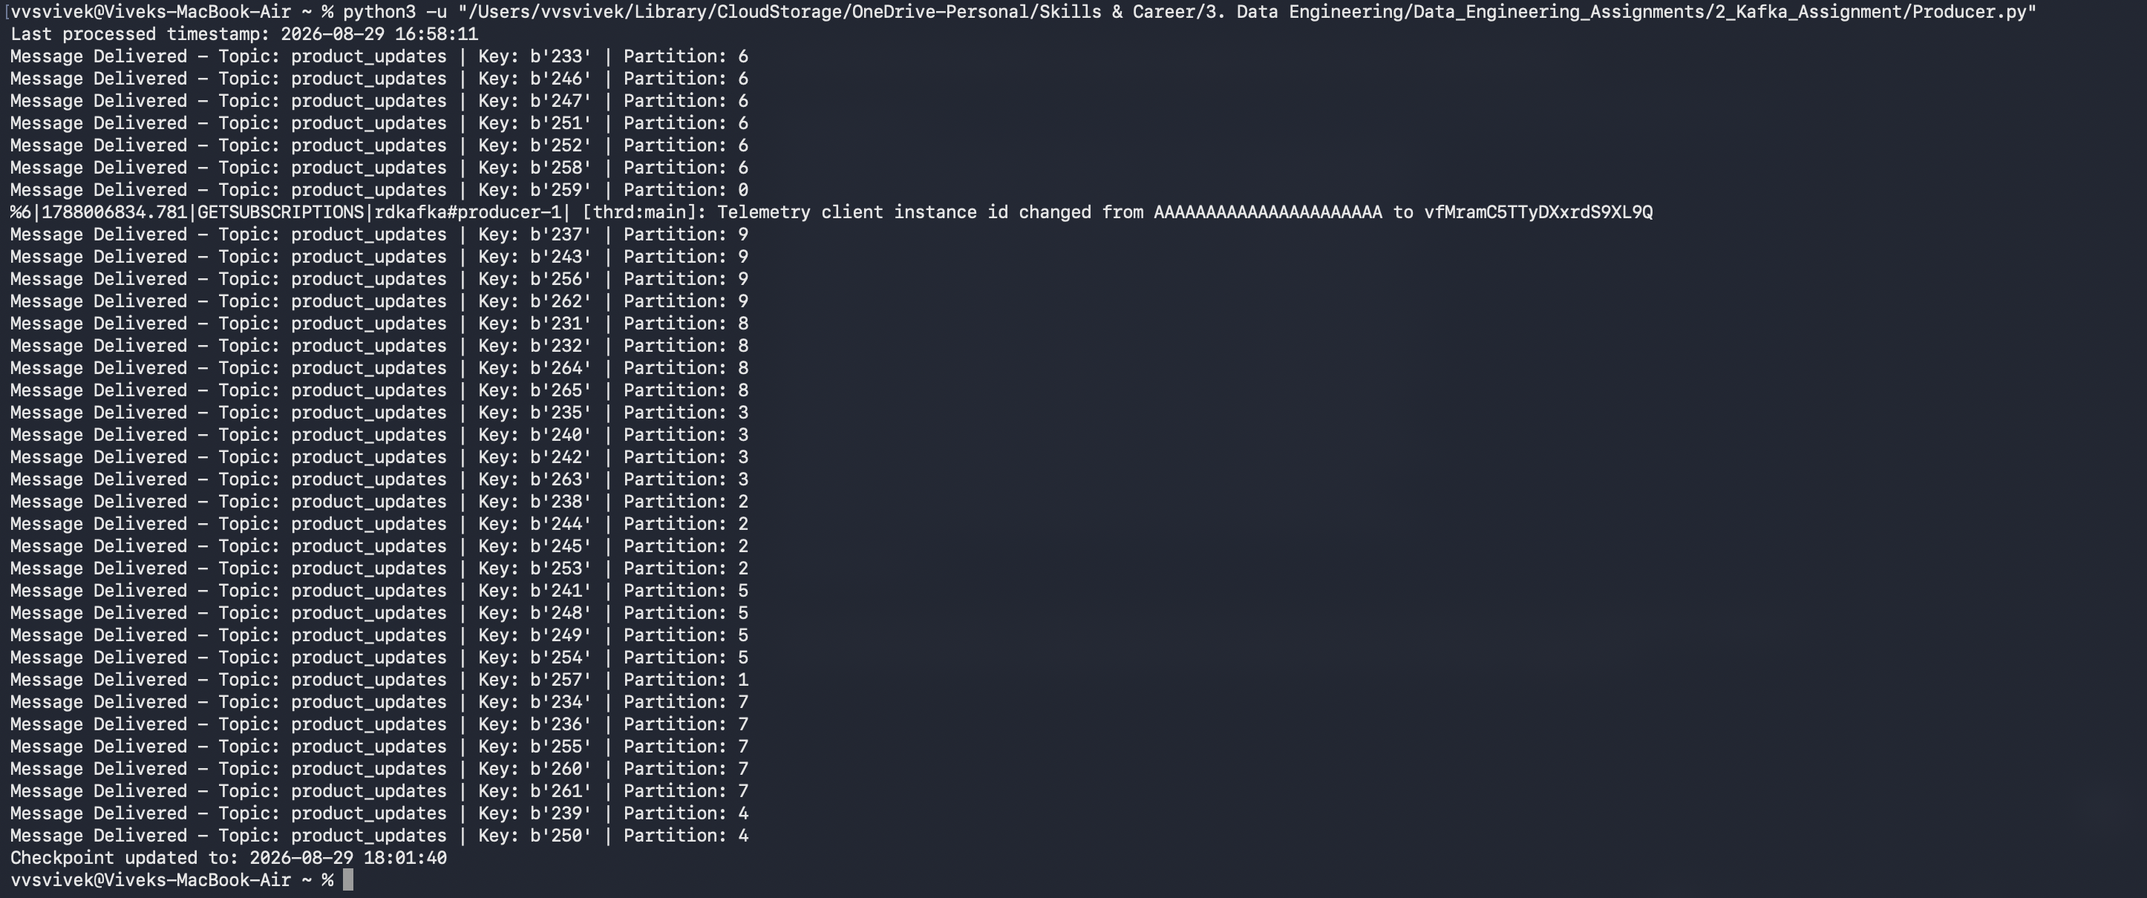
- Once the messages are sent to kafka topic, we execute the consumer. The consumer will create 5 instances of the consumer, each consumer will then fetch data from the kafka topic and dump it in its json file.
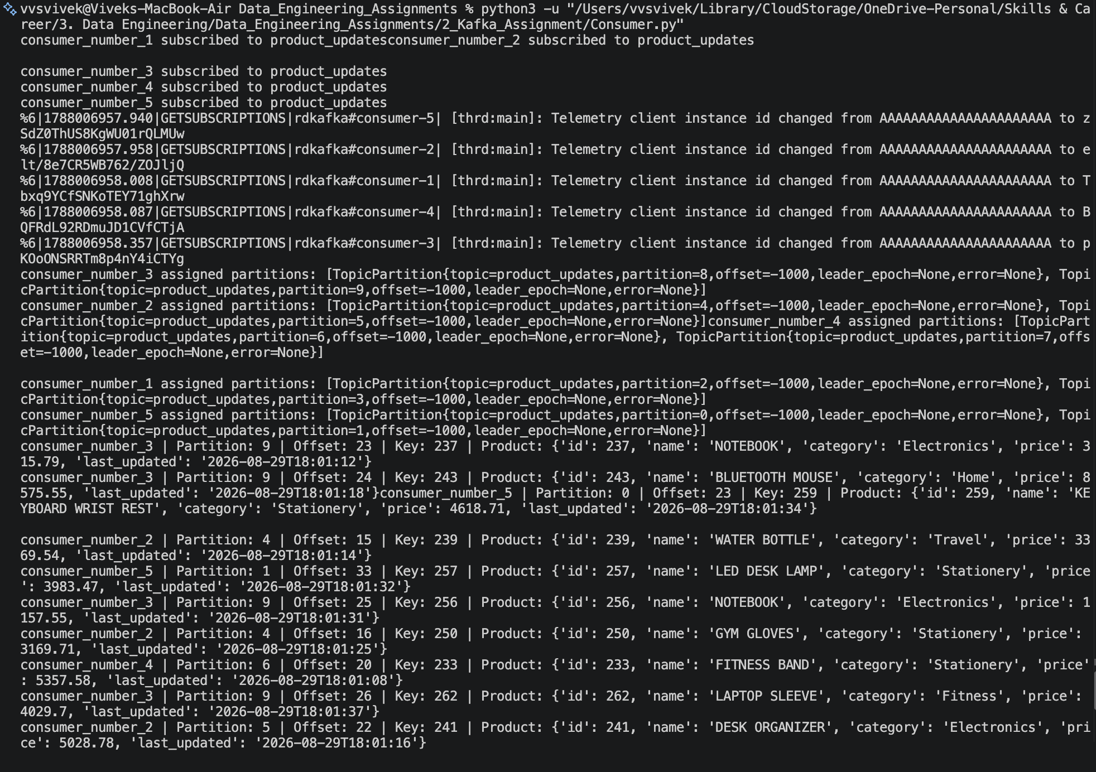
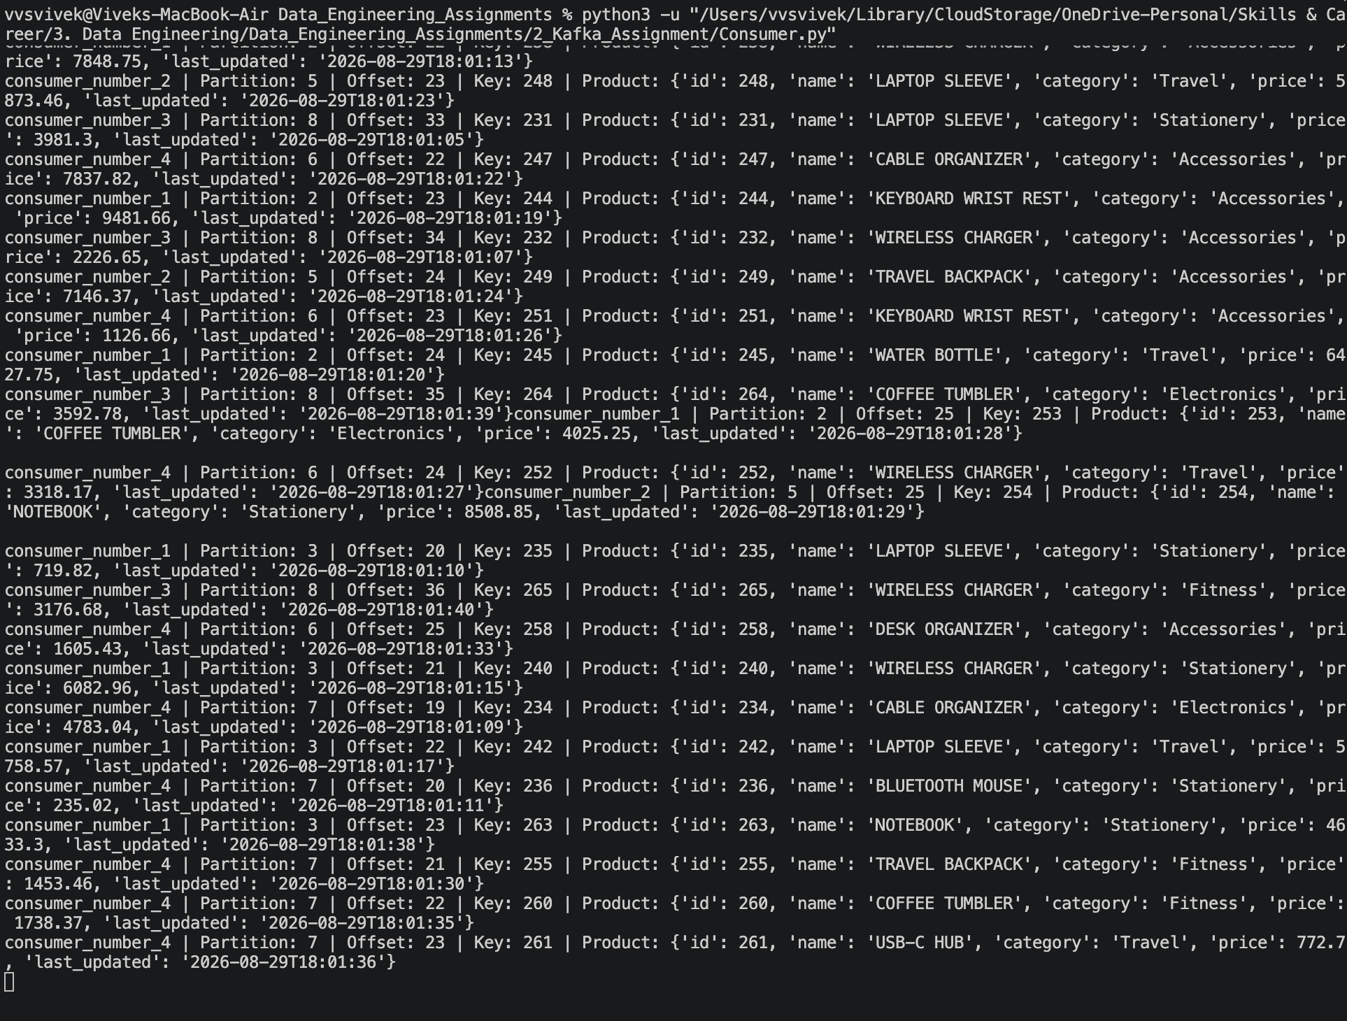

Json files:
